Daily Checks

- Clean gripper head and heater bars with wet rag.

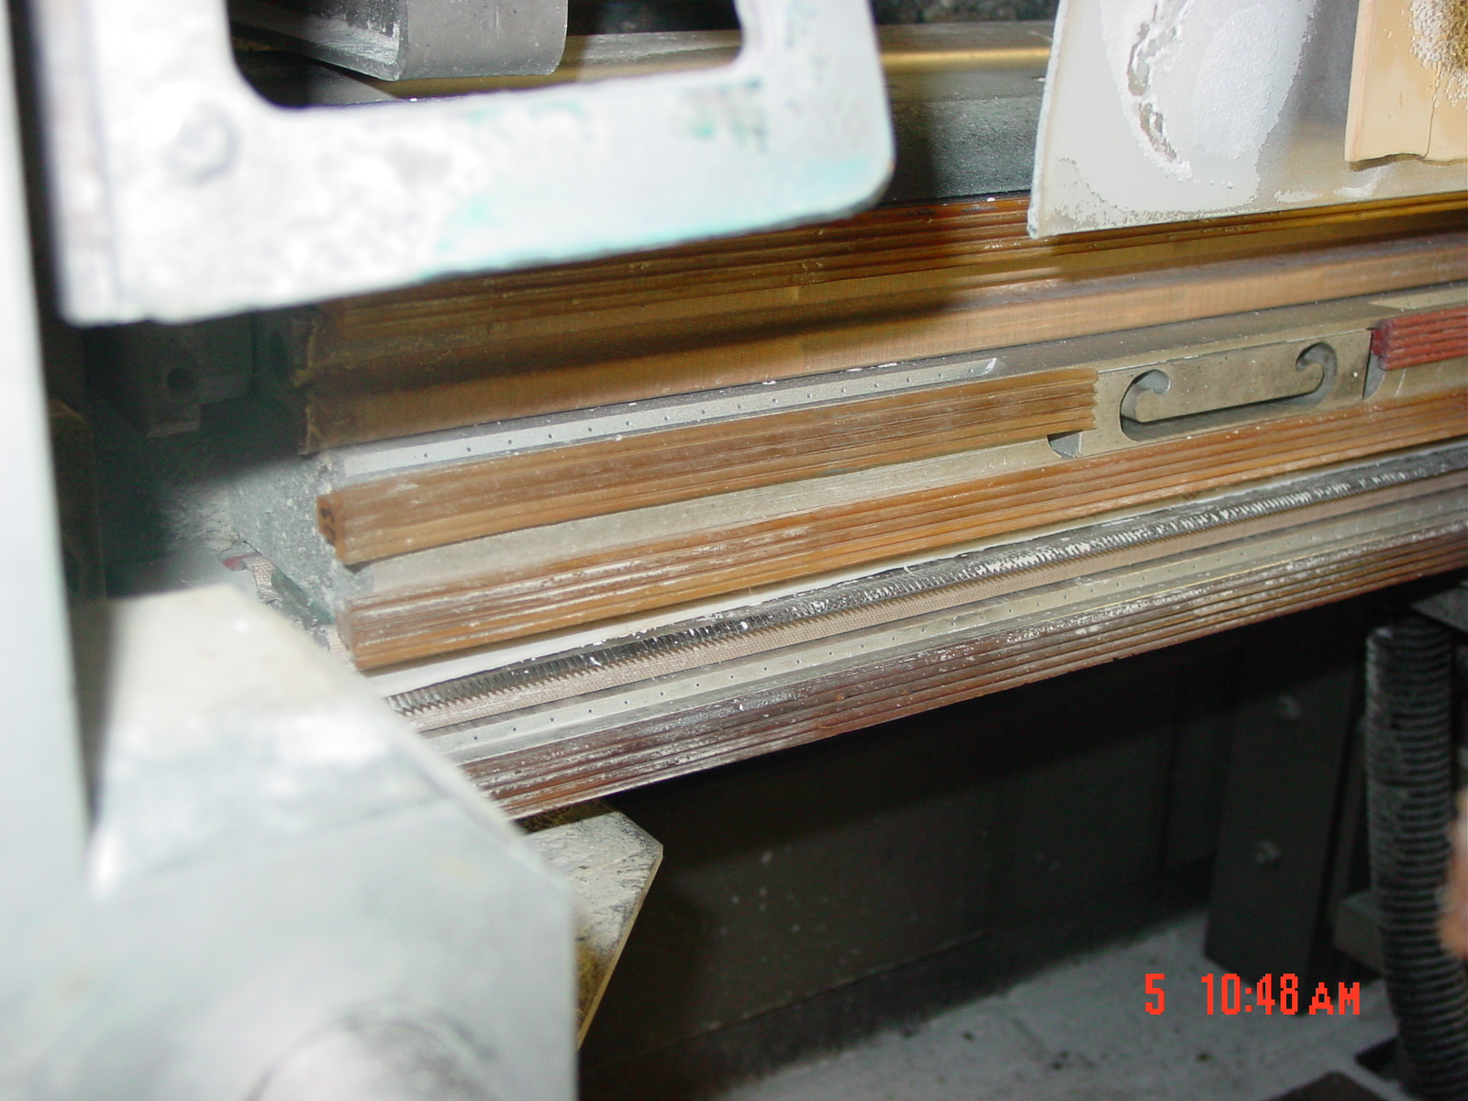
Thoroughly clean gripper strips and knife

- Clean area around machine.
- Check conveyors for wear, alignment, etc.
- Clean formatting head with ink conditioner.

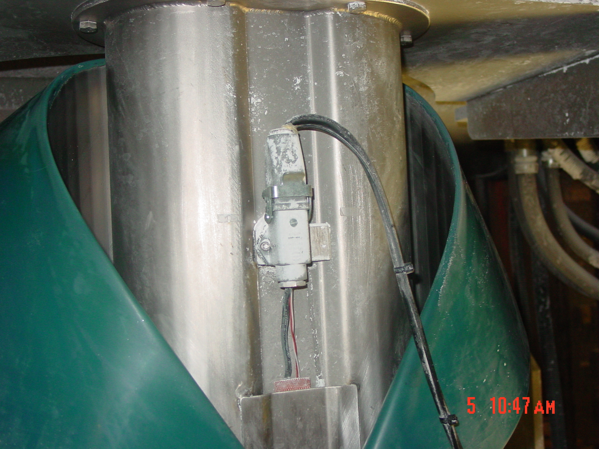
Thoroughly clean inside edge and outside of formatting head with ink conditioner

- Clean pinch rollers with ink conditioner
  - (see Weekly Cleaning instructions for more detail)
- Clean eye mark sensor (see weekly cleaning for detailed instructions)
- Zero scales (see Shift Checklist for detailed instructions)

TRAINING DOCUMENTATION

 | EMPLOYEE | TITLE | SIGNATURE | DATE
1
2
3
4
5
6
7
8
9
10
11
12
13
14
15
16
17
18

